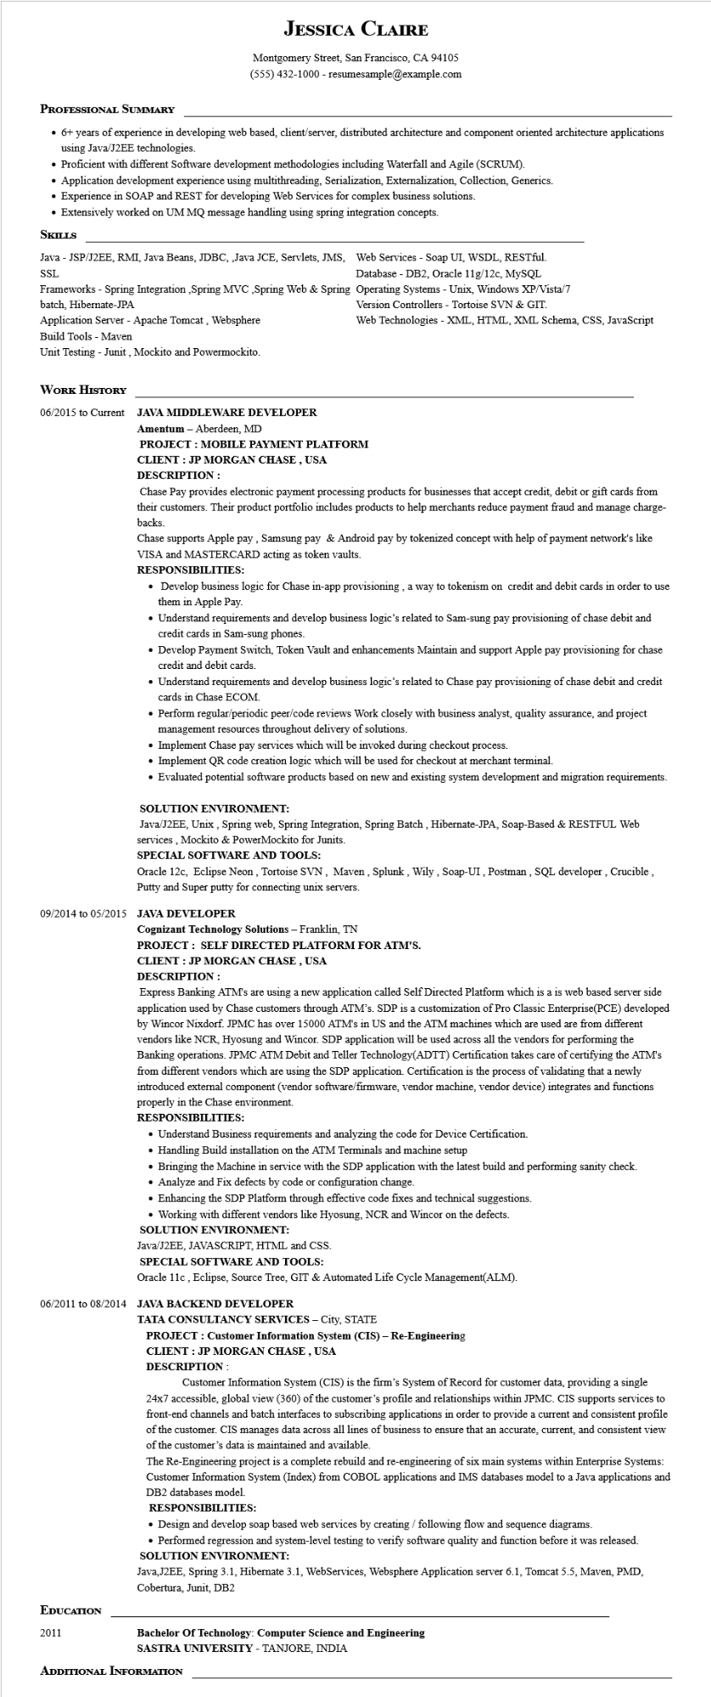
JESSICA CLAIRE
Montgomery Street, San Francisco, CA 94105
(555) 432-1000 - resumesample@example.com
PROFESSIONAL SUMMARY
• 6+ years of experience in developing web based, client/server, distributed architecture and component oriented architecture applications using Java/J2EE technologies.
• Proficient with different Software development methodologies including Waterfall and Agile (SCRUM).
• Application development experience using multithreading, Serialization, Externalization, Collection, Generics.
• Experience in SOAP and REST for developing Web Services for complex business solutions.
• Extensively worked on UM MQ message handling using spring integration concepts.
SKILLS
Java - JSP/J2EE, RMI, Java Beans, JDBC, Java JCE, Servlets, JMS, Web Services - Soap UI, WSDL, RESTful. SSL
Database DB2, Oracle 11g/12c, MySQL
Frameworks - Spring Integration,Spring MVC,Spring Web & Spring Operating Systems - Unix, Windows XP/Vista/7 batch, Hibernate-JPA
Application Server - Apache Tomcat, Websphere
Build Tools - Maven
Unit Testing - Junit, Mockito and Powermockito.
WORK HISTORY
06/2015 to Current JAVA MIDDLEWARE DEVELOPER
Amentum - Aberdeen, MD
Version Controllers - Tortoise SVN & GIT.
Web Technologies - XML, HTML, XML Schema, CSS, JavaScript
PROJECT: MOBILE PAYMENT PLATFORM
CLIENT : JP MORGAN CHASE, USA
DESCRIPTION:
Chase Pay provides electronic payment processing products for businesses that accept credit, debit or gift cards from their customers. Their product portfolio includes products to help merchants reduce payment fraud and manage charge- backs.
Chase supports Apple pay, Samsung pay & Android pay by tokenized concept with help of payment network's like VISA and MASTERCARD acting as token vaults.
RESPONSIBILITIES:
• Develop business logic for Chase in-app provisioning, a way to tokenism on credit and debit cards in order to use them in Apple Pay.
• Understand requirements and develop business logic's related to Sam-sung pay provisioning of chase debit and credit cards in Sam-sung phones.
• Develop Payment Switch, Token Vault and enhancements Maintain and support Apple pay provisioning for chase credit and debit cards.
• Understand requirements and develop business logic's related to Chase pay provisioning of chase debit and credit cards in Chase ECOM.
• Perform regular/periodic peer/code reviews Work closely with business analyst, quality assurance, and project management resources throughout delivery of solutions.
• Implement Chase pay services which will be invoked during checkout process.
• Implement QR code creation logic which will be used for checkout at merchant terminal.
• Evaluated potential software products based on new and existing system development and migration requirements.
SOLUTION ENVIRONMENT:
Java/J2EE, Unix, Spring web, Spring Integration, Spring Batch, Hibernate-JPA, Soap-Based & RESTFUL Web services, Mockito & PowerMockito for Junits.
SPECIAL SOFTWARE AND TOOLS:
Oracle 12c, Eclipse Neon, Tortoise SVN, Maven, Splunk, Wily, Soap-UI, Postman, SQL developer, Crucible, Putty and Super putty for connecting unix servers.
09/2014 to 05/2015 JAVA DEVELOPER
Cognizant Technology Solutions - Franklin, TN
PROJECT: SELF DIRECTED PLATFORM FOR ATM'S.
CLIENT : JP MORGAN CHASE, USA
DESCRIPTION:
Express Banking ATM's are using a new application called Self Directed Platform which is a is web based server side application used by Chase customers through ATM's. SDP is a customization of Pro Classic Enterprise(PCE) developed by Wincor Nixdorf. JPMC has over 15000 ATM's in US and the ATM machines which are used are from different vendors like NCR, Hyosung and Wincor. SDP application will be used across all the vendors for performing the Banking operations. JPMC ATM Debit and Teller Technology (ADTT) Certification takes care of certifying the ATM's from different vendors which are using the SDP application. Certification is the process of validating that a newly introduced external component (vendor software/firmware, vendor machine, vendor device) integrates and functions properly in the Chase environment.
RESPONSIBILITIES:
• Understand Business requirements and analyzing the code for Device Certification.
• Handling Build installation on the ATM Terminals and machine setup
• Bringing the Machine in service with the SDP application with the latest build and performing sanity check.
• Analyze and Fix defects by code or configuration change.
• Enhancing the SDP Platform through effective code fixes and technical suggestions.
• Working with different vendors like Hyosung, NCR and Wincor on the defects.
SOLUTION ENVIRONMENT:
Java/J2EE, JAVASCRIPT, HTML and CSS.
SPECIAL SOFTWARE AND TOOLS:
Oracle 11c, Eclipse, Source Tree, GIT & Automated Life Cycle Management(ALM).
06/2011 to 08/2014 JAVA BACKEND DEVELOPER
TATA CONSULTANCY SERVICES - City, STATE
PROJECT : Customer Information System (CIS) - Re-Engineering
CLIENT : JP MORGAN CHASE, USA
DESCRIPTION:
Customer Information System (CIS) is the firm's System of Record for customer data, providing a single 24x7 accessible, global view (360) of the customer's profile and relationships within JPMC. CIS supports services to front-end channels and batch interfaces to subscribing applications in order to provide a current and consistent profile of the customer. CIS manages data across all lines of business to ensure that an accurate, current, and consistent view of the customer's data is maintained and available.
The Re-Engineering project is a complete rebuild and re-engineering of six main systems within Enterprise Systems: Customer Information System (Index) from COBOL applications and IMS databases model to a Java applications and DB2 databases model.
RESPONSIBILITIES:
• Design and develop soap based web services by creating / following flow and sequence diagrams.
• Performed regression and system-level testing to verify software quality and function before was released.
SOLUTION ENVIRONMENT:
Java, J2EE, Spring 3.1, Hibernate 3.1, WebServices, Websphere Application server 6.1, Tomcat 5.5, Maven, PMD, Cobertura, Junit, DB2
EDUCATION
2011
Bachelor of Technology: Computer Science and Engineering
SASTRA UNIVERSITY - TANJORE, INDIA
ADDITIONAL INFORMATION

